Systems Engineering Evaluation of Aircraft Boarding Strategies Using Discrete‑Event Simulation

Abstract
This report made use of the core principles of systems engineering to critically evaluate the strategies in passenger boarding, particularly for single-aisle, aircrafts’ with single doors, making use of an event simulation digital twin. The first thing created to establish a unique benchmark was the base model, which represents the random boarding. There were four boarding strategies that helped to create an objective comparison. These boarding strategies were modelled and stimulated through identical assumptions. To have a holistic approach and full analysis, certain key performance indicators were analyzed. Key performance indicators such as total boarding time, process predictability, and even behaviors that cause an interference with the passengers. Flow stability was improved due to the reduction of aisle congestion, which was a result of the boarding strategies outperforming the default random approach obtained through the simulation results.
Well-structured zoning and seat position strategies provide a certain level of reduction and create ease in operations, while, on the other hand, simple front-to-back boarding only provides time savings. The study critically evaluates the results obtained in systems engineering, paying close attention to certain factors such as health, safety, regulatory, societal, environmental, and even commercial factors. The most effective solution to implement, which will help to balance the efficiency gains with full operational capabilities, is the hybrid rear-to-front strategy.

1. Introduction
The time taken for an aircraft to turn around is seen as critical in nature as it directly affects the efficiency in the aircraft's operations, profitability, and how long the aircraft can last during the scheduled flights, especially the short-haul and low-cost carriers that solely depend on how the aircraft is utilized. During the turnaround sequence, the longest and most variable process is believed to be the process of passenger boarding as it goes beyond refueling and catering durations. When delays occur during boarding, there is the tendency to propagate through the flight network which causes overtime of work done by the members of the crew, slots missed, and the most important of them all, a reduction in the customers’ satisfaction as time is lost.
The boarding process creates a complex system which can be seen as socio-technical as it intersects the human behavior, physical aircraft constraints, and rules on which the operation is built. There has been a huge struggle to capture this complex system using the traditional approach. This study made use of the system engineering approach, which is uses event simulation to model the flow of passengers, understand limitations, and make decisions based on evidence provided.
The report’s objectives include:
- To develop a digital twin of the boarding process using Witness Horizon, specific to aircraft.
- To use random boarding to establish a base model.
- To devise four unique alternative boarding strategies.
- To carry out a structured comparison of strategies using quantitative KPIs.
- To consider regulatory, safety, societal, and environmental limitations when suggesting recommendations.

2. Methodology and Systems Engineering Approach
The report made use of a structural holistic model that evaluates lifecycle, system modelling, evaluation, and recommendation. The boarding process is divided into different segments, like gate processing, passenger movement along the jet bridge, dynamics on the aisle alongside the cabin, hand luggage stowage, and access to seats. A keen attention is placed on the interfaces that exist between the subsystems. In Witness Horizon, an event simulation was developed to act as a digital twin during the boarding process. This event simulation fits in smoothly with the operations done at the airport, such as queuing, resource contention, and the behavior of passengers. All the models were created using identical layouts, logic structures. This is to ensure that the performances observed are different.

2.1 Aircraft and Passenger Assumptions
The nominal aircraft model contains a different body configuration when compared to an Airbus A320 or Boeing 737, when 100 passengers are seated in an arrangement of four seats per row and a total of 25 rows, with a single aisle and a single forward boarding door. The seats are all occupied, there is no single priority boarding, and no late passengers as they all arrive on time at the gate. All the passengers on board have one hand luggage, which is kept only in the overhead bins that are above their assigned rows.

2.2 Stochastic Input Data
All processing times were modelled to ensure that real-world variability is reflected by making use of the probability distributions through published airport operations literature. The use of a triangular distribution helped to model the time spent scanning the boarding pass. Other models were also considered, which made use of the time taken to walk on the jet bridge using a normal distribution, time spent in cabin walking per row using a uniform distribution, time spent using the hand luggage stowage using a lognormal distribution, and if any seat interference delay occurs, which makes use of the triangular distribution. In order to control any variables that occurred, random numbers in line with the assessment requirements were used to ensure that the results are credible.

3. Boarding Strategies Modelled

3.1 Base Model – Random Boarding
The first-come, first-served approach is often linked to the base model as passengers board the aircraft as a single undifferentiated group. The assignment of seats is usually not in an organized system, as they are random. This approach shows the default practice that is in place by many low-cost carriers. This establishes a benchmark and creates room for well-structured comparisons of alternative strategies.
In the base model, passengers board the aircraft as a single undifferentiated group on a first‑come, first‑served basis. Seat assignments are random and no pre‑queueing or zoning is applied. This strategy reflects the default practice adopted by many low‑cost carriers and provides a benchmark against which alternative strategies can be evaluated.

Figure 1: Base Model – Random Boarding Strategy (Witness Horizon)
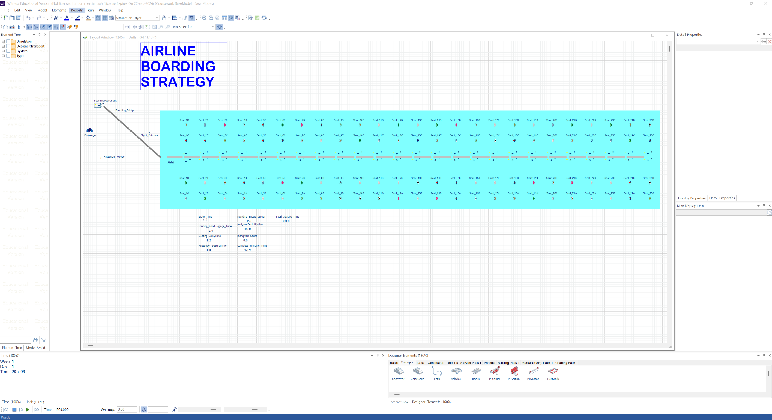

3.2 Strategy 1 – Front‑to‑Back Boarding
The core aim of this strategy is to ensure there is a reduction in the flows and passengers’ behavior of overtaking within the aisle. This strategy is the front-to-back boarding model, where passengers exist in a sequential manner. This usually starts from the front of the aircraft and then down the rear.

Figure 2: Front‑to‑Back Boarding Strategy (Witness Horizon)
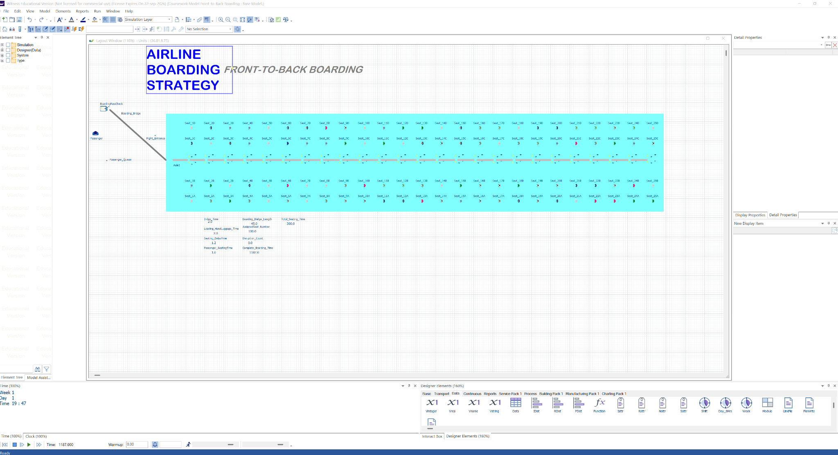

3.3 Strategy 2 – Back‑to‑Front Boarding
This approach aims to reduce any instances where the passengers have to pass through passengers who are already seated and reduce any aisle interference. This back-to-front boarding approach uses the opposite of the front-to-back approach.

3.4 Strategy 3 – Window ‑Aisle (WA) Boarding
This approach aims to reduce any seat interferences, although it needs strict compliance by the passengers and a clear gate management system. The Window-aisle approach creates a system where passengers board the aircraft on the basis of their seat position and not their row order.

3.5 Strategy 4 – Hybrid Rear‑to‑Front Zoned Boarding (Recommended)
This approach creates a divide in the cabin by creating the rear-to-front zones and establishing five rows. This approach allows passengers, when boarding, to use the outside-in sequence from within each zone. This approach merges the advantages gained from a reduced interference on the aisle from rear boarding with reduced seat interference.

4. Results and Analysis
With the support of qualitative assessment of congestion and stability of flow of the aisle, the simulation outputs were thoroughly analyzed by establishing the primary KPI as the total boarding time.

Boarding Strategy | Total Boarding Time (s) | Relative Performance
Random Boarding (Base) | 1209 | Baseline
Front‑to‑Back | 1187 | ≈1.8% improvement
Back‑to‑Front | 1145 | Moderate improvement
Window‑Aisle | 1108 | High improvement
Hybrid Zoned Strategy | 1085 | Best overall performance
Following the results above, a trend is seen that increases the structural organization of leads during boarding, creates a reduction in time spent during boarding, and overall improves predictability. The strategy that performs the least is the random boarding strategy, as there are frequent seat interferences. The front-to-back approach presents a limited marginal improvement, as passengers who are in the adjacent rows over time tend to compete for the overhead bin space. The hybrid approach, for instance, amongst other more structured approaches, tends to create a reduction in the interference and establishes the lowest boarding time.

5. Regulatory, Safety, and Societal Considerations
There is a direct implication on health and safety that arises from efficient boarding. The risk of slips, trips, and processes involved in handling injuries is lowered thanks to reduced aisle congestion. Passenger flexibility must be prioritized as it helps passengers with reduced mobility, and those requiring assistance, are of these can be achieved with a structured boarding system.
Looking at it from an environmental view, the reduction in time spent during boarding can reduce the auxiliary power unit usage at the gate, which further contributes to the reduction in emissions. On the commercial aspect, an improved boarding efficiency creates a certain reliability for the passengers as they trust the schedule, makes the aircraft fully utilized, and helps to make the airline more profitable.

6. Conclusion and Recommendations
In this report, there has been a keen attention on the value of systems engineering and the event simulation, which is critical when evaluating complex processes operationally. Although the simple structured approach creates certain limitations, the hybrid approach presents a substantial improvement without much operational complexity. It is recommended that airlines operating single‑aisle aircraft use the rear‑to‑front zoned boarding strategy, which has an outside‑in sequence that supports clear gate communication and flexibility for accessibility needs.

References
Ashford, N., Mumayiz, S. and Wright, P. (2011) Airport Engineering. 4th edn. Wiley.
Banks, J. et al. (2010) Discrete‑Event System Simulation. 5th edn. Pearson.
Bazargan, M. (2016) Airline Operations and Scheduling. Routledge.
Endsley, M.R. (2017) Human Factors, 59(1), pp. 5–27.
ICAO (2018) Airport Services Manual Part 8. ICAO.
ICAO (2019) Environmental Protection – Aircraft Engine Emissions. ICAO.
INCOSE (2015) Systems Engineering Handbook. Wiley.
Nyquist, D.C. and McFadden, K.L. (2008) Journal of Air Transport Management, 14(4), pp. 197–204.
Steffen, J.H. (2008) Journal of Air Transport Management, 14(3), pp. 146–150.
Steffen, J.H. and Hotchkiss, J. (2012) Journal of Air Transport Management, 18(1), pp. 64–67.

